 

**Placement Empowerment Program**

***Cloud Computing and DevOps Centre***

60 Days of DevOps Challenge

***Day 1: Linux Basics - Commands, File System, Users & Permissions***

***Name: Mary Edlyn A Department: CSE***



This Proof of Concept (PoC) demonstrates the Linux Basics Shell Scripting, Managing Processes, Using Package Managers, Basic Networking Commands and Editing Configuration Files.

**Challenge 1**: **List all files (including hidden ones) in your home directory and sort them by modification time.**

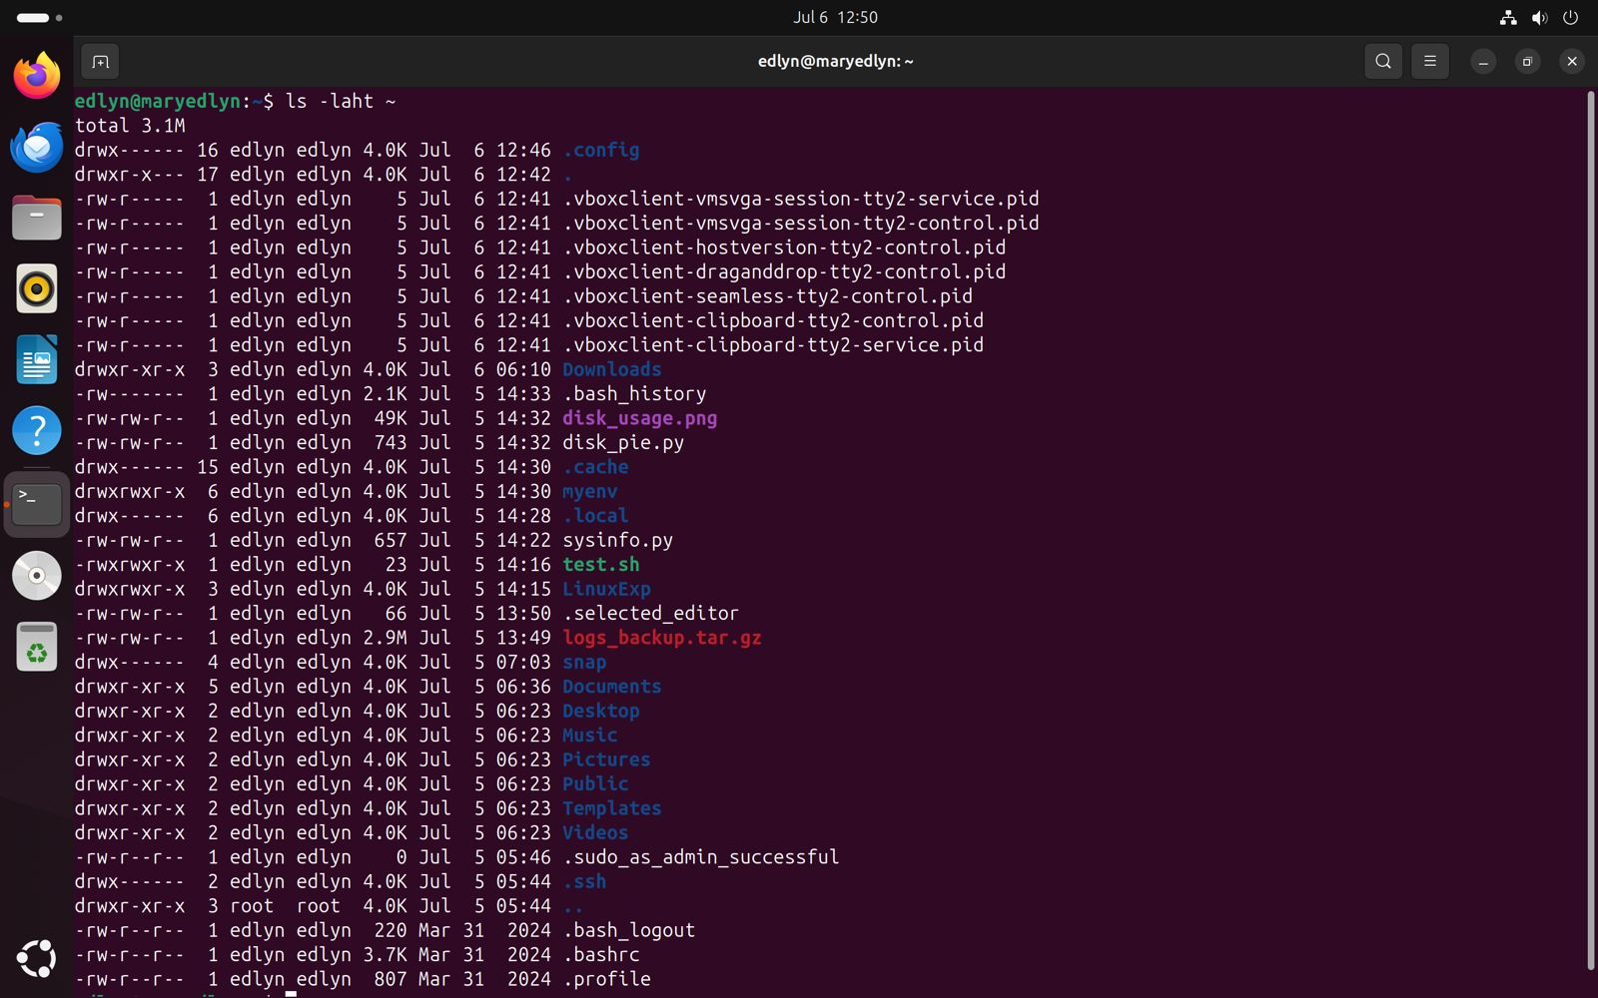

**Challenge 2**: **Create a directory named**devops_challenge_day_1**, navigate into it, and create an empty file named**day1.txt**.**

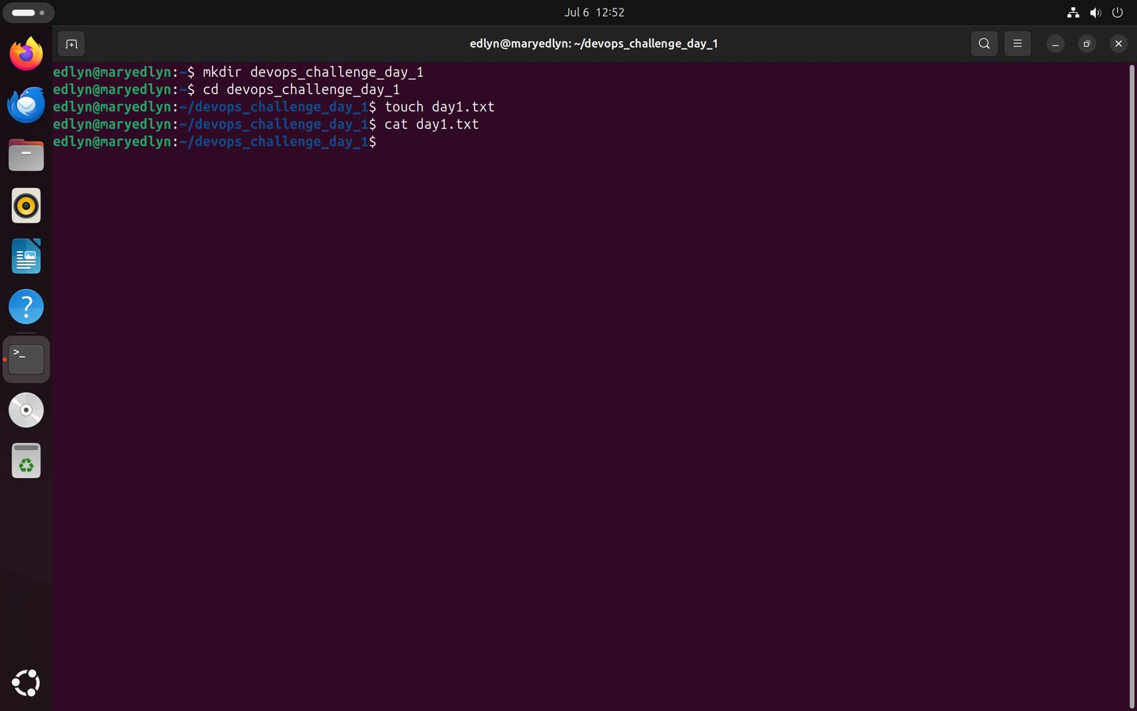

**Challenge 3: Find the total disk usage of the**/var/log**directory in human-readable format.**.

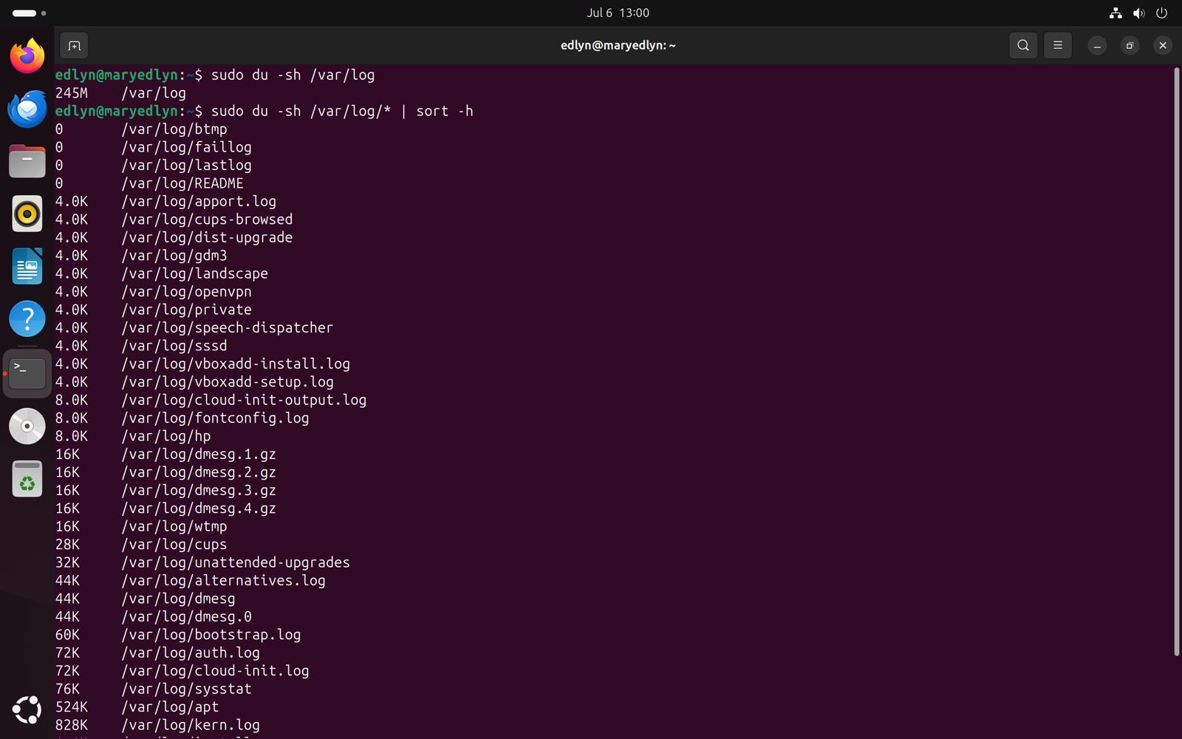

**Challenge 4**: **Create a new user called**devops_user**and add them to the**sudo**group.**

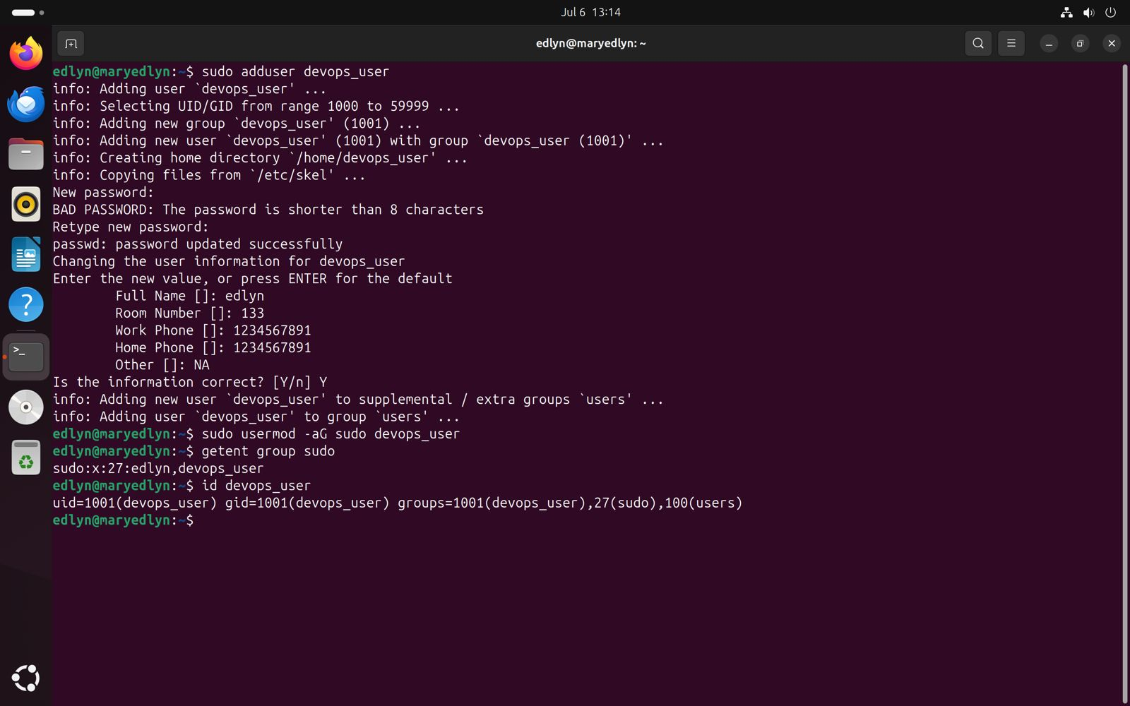

**Challenge 5**:  **Create a group called**devops_team**and add**devops_user**to that group.**

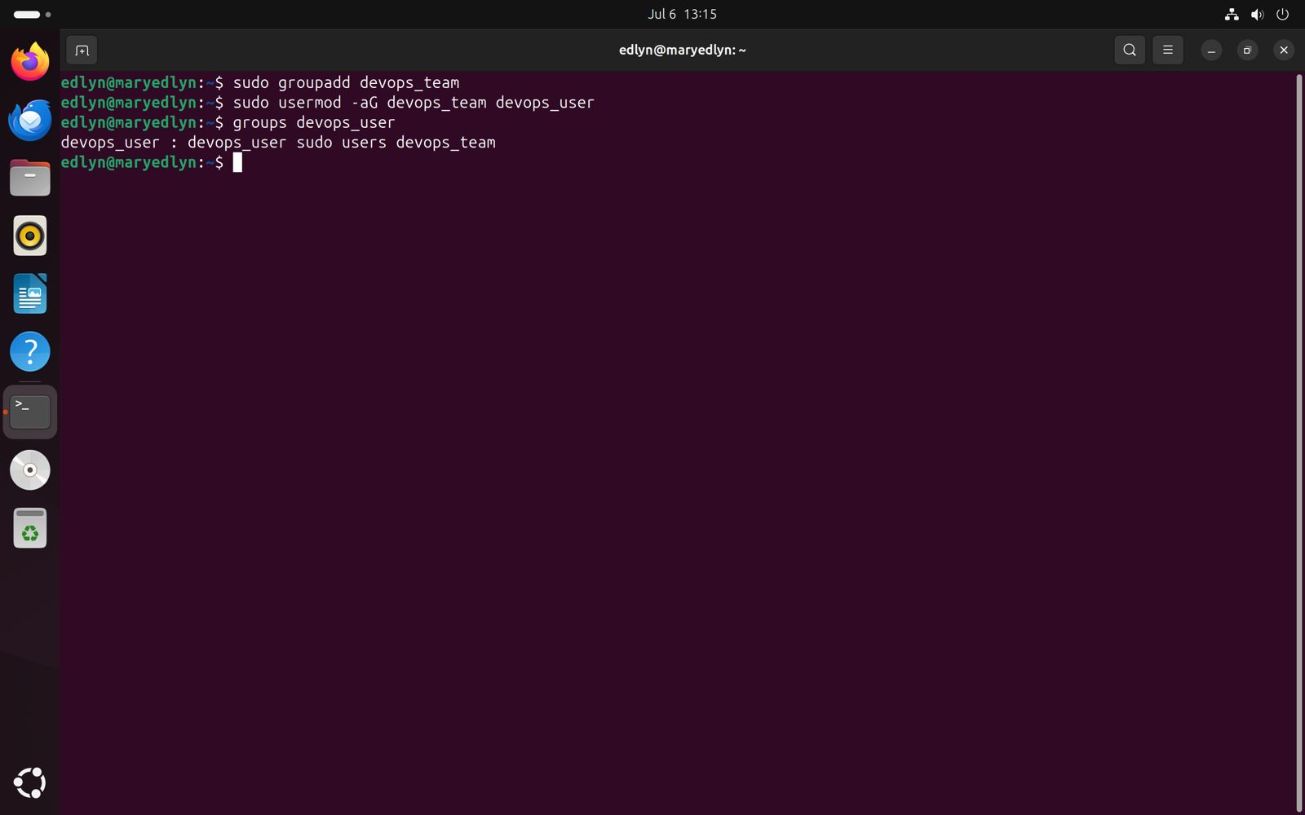

**Challenge 6**: **Change the permissions of**day1.txt**to allow only the owner to read and write, but no permissions for others.**

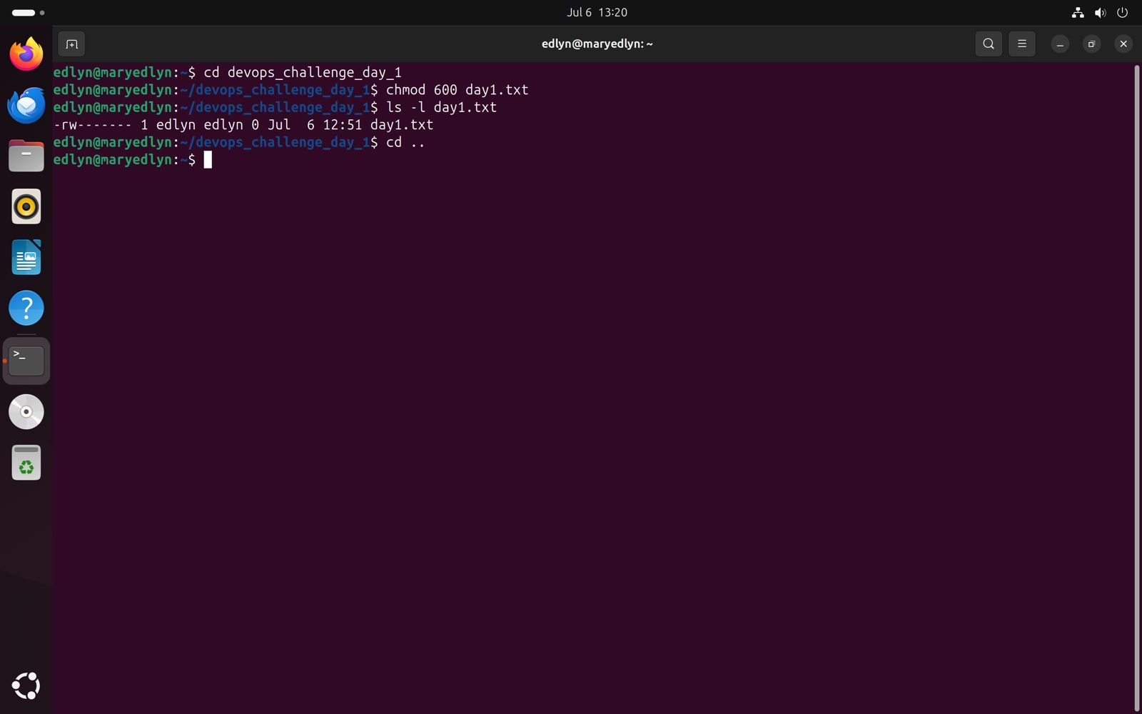

**Challenge 7: Write a one-liner command to find the most frequently used command in your shell history.**

